Story of Positive Impact
Project : KfW Soil Project

- Project Village :- Lachhanadih

- Farmer’s Name:- Nuneshwar Yadav Mob. No.- 7542091383

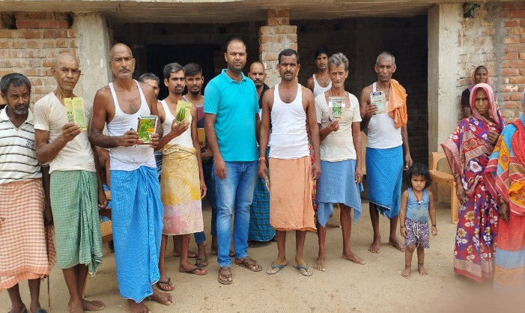
- Address :- At- Lachhanadih, P.O -Mothabari, PS- Katoria, Dist.-Banka Pin-813106.

- Name of Activity:- Kitchen Garden
- Month of Initiation:- April 2022

- Problem Statement :-
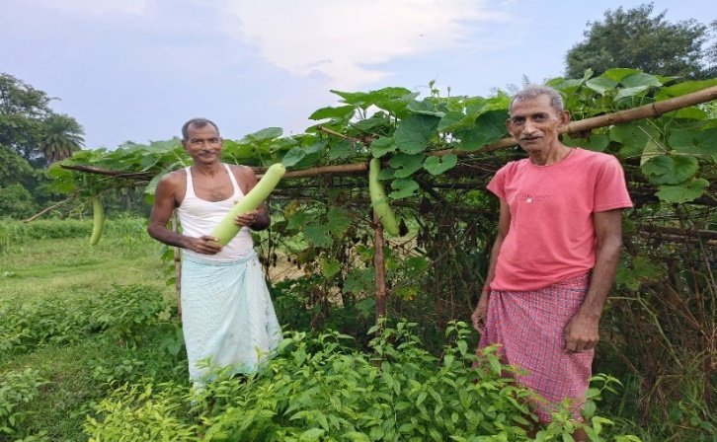
Farmers can not buy green vegetables and their food content is not balance. This year there has been complete failure of monsoon. The farmer has gone to hand to month.
- Initiation Taken :-
Under Kitchen Garden Scheme Nuneshwar was selected. He promised to follow all norms. He bounded the area, ploughed properly, removed weeds, put compost in the soil and sowed the seeds. Proper care was given on dressing and irrigating. Plants grew well flowering and fruiting resulted in time.

- Progress And Result :-
Fruiting was very nice, Everywhere in and around the villages there was shortage of green vegetable consumes like local vegetables. They organic products. Nuneshwar was encouraged. He did not loose patience. He started selling vegetables. Quality was very good. Fresh Vegetables Were appreciated everywhere. He spent his bad days and he is happy to enjoy the fruit of labour.
The water of the Lachhana Checkdam proved a boon to him.

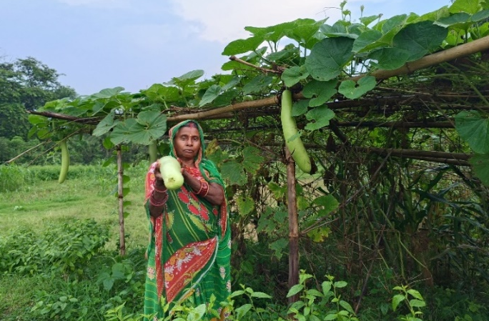
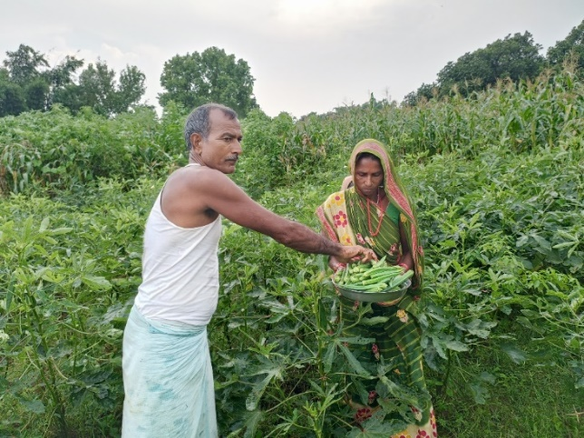
- Impact:-
The dire necessity of the family, for a shot period, could be et up with selling of vegetables people appreciated and he feels satisfied.

- Inspiration :-
Land gives $≠$ life and livelihood.
Labour never goes in vain.

